APL materials

SUPPLEMENTARY MATERIALS

Demonstrating the high sensitivity of MoS2 monolayers for direct X-ray detectors

Alberto Taffelli a*, Max Heyl b, Matteo Favaro a , Sandra Dirè a , Lucio Pancheri a, Emil J. W. List-Kratochvil b,c , Alberto Quaranta a,d , and Giovanni Ligorio b*

**AFFILIATIONS**

a. Department of Industrial Engineering, University of Trento, Via Sommarive 9, 38123 Trento, Italy

b. Institute für Physik, Institute für Chemie & IRIS Adlershof, Humboldt-Universität zu Berlin, Zum Großen Windkanal 2, 12489 Berlin, Germany  
c. Helmholtz-Zentrum Berlin für Materialien und Energie GmbH, Hahn-Meitner-Platz 1, 14109 Berlin, Germany

d. INFN-TIFPA, via Sommarive 14, 38123 Trento, Italy

*Correspondence: [alberto.taffelli@unitn.it](mailto:alberto.taffelli@unitn.it), [giovanni.ligorio@hu-berlin.de](mailto:giovanni.ligorio@hu-berlin.de)

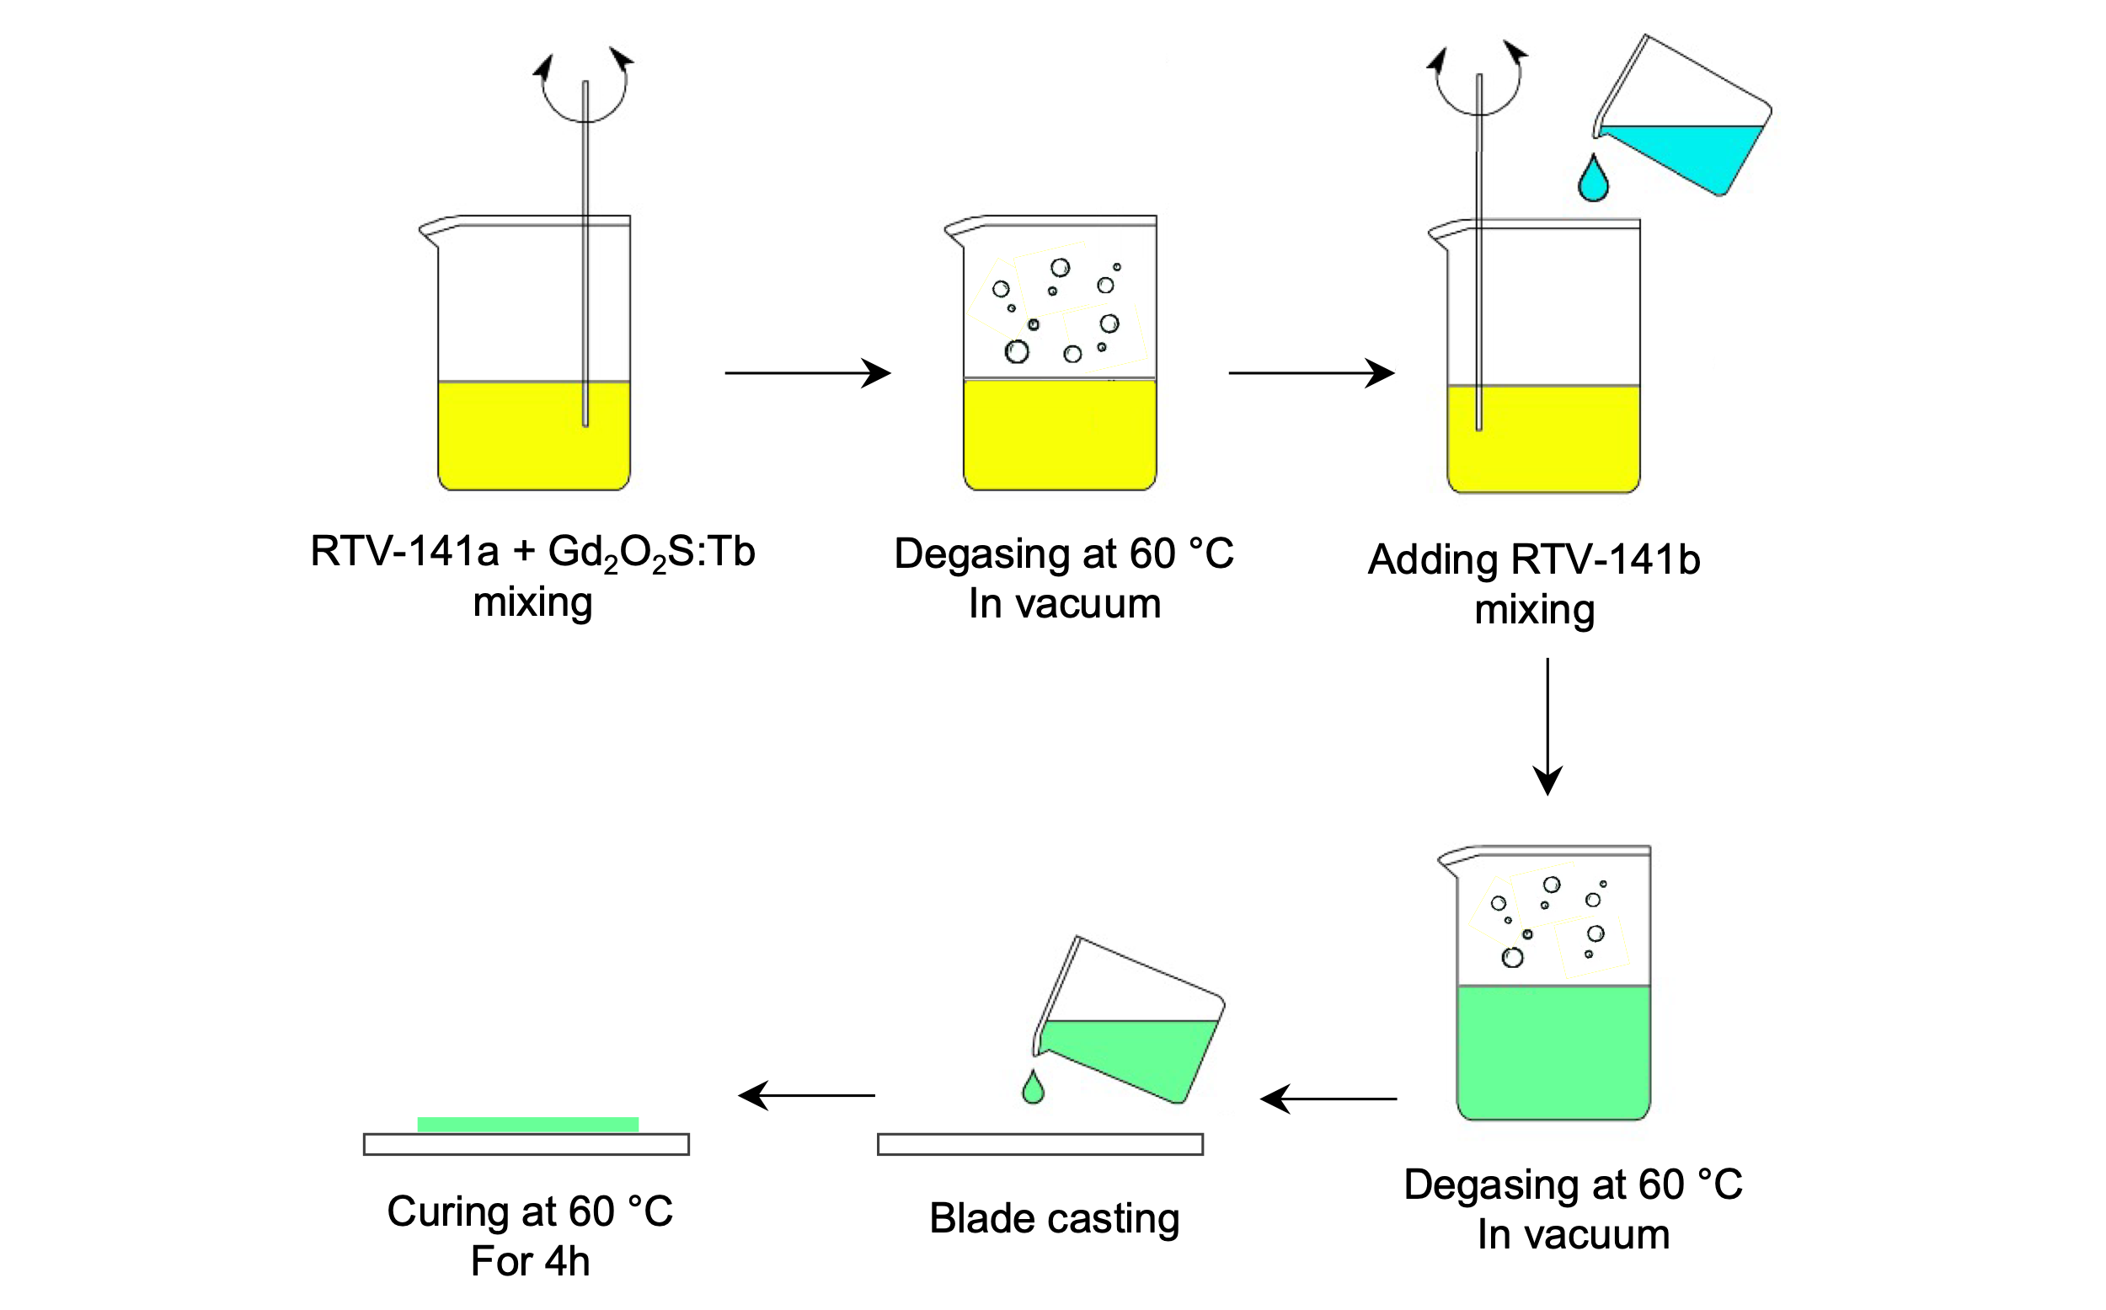

Figure S1: scheme of the steps of the fabrication of scintillator films based on PDMS loaded with Gd2O2S:Tb. Gd2O2S:Tb powder (0.5% wt) was added to the base PDMS component (Bluesil RTV 141-a), mixed and degassed in a vacuum oven at 60 °C. The reactive PDMS component (Bluesil RTV 141-b) was added in a 10:1 mass ratio with respect to the base component, followed by degassing in a vacuum oven at 60 °C. (Figure S1). Finally, the solution was casted via blade casting and cured at 60 °C for 4h.

Table S1: Thorlabs LEDs models, nominal wavelength, and irradiance on the detector

|  |  |  |
| --- | --- | --- |
| LED Model | Wavelength (nm) | Irradiance (μW/mm2) |
| M340L4 | 340 | 2.22 |
| M375L4 | 375 | 13.71 |
| M405L4 | 405 | 14.53 |
| M455L4 | 455 | 31.20 |
| M505L4 | 505 | 11.10 |
| M565L4 | 565 | 11.70 |
| M590L4 | 590 | 5.30 |
| M625L4 | 625 | 18.00 |
| M660L4 | 660 | 17.41 |
| M730L4 | 730 | 13.20 |
| M850L4 | 850 | 19.08 |
| M940L4 | 940 | 19.10 |

Figure S2: Characterization of MoS2 monolayers exfoliated from the same parental MoS2 crystal of the device. a) Optical microscope image identifying single and double MoS2 layer regions; b) photoluminescence spectra and Raman spectra acquired on the same regions.

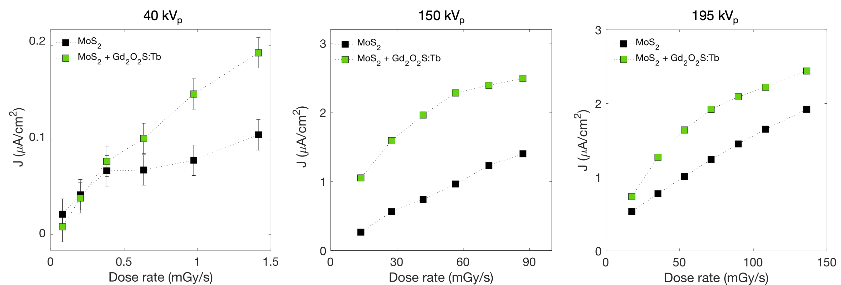

Figure S3: Photocurrent densities under different X-ray energies for the detector based on 2D-MoS2 (black marks) compared detector based on MoS2 + scintillator (green marks). In the plot on the right (40kV), where the measurements are affected by significant fluctuations, the errorbars representing the standard deviation are displayed. The detector was operated at 5 V during these measurements.

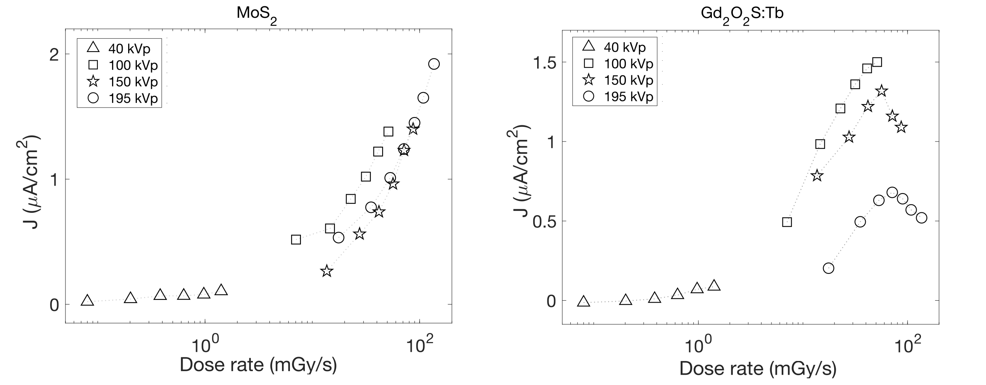

Figure S4: Photocurrent densities for the detector based on 1L-MoS2 only under different X-ray energies (left). b) scintillator contribution to the photocurrent from the scintillator only for the same X-ray energies. The detector was operated at 5 V during the measurements.

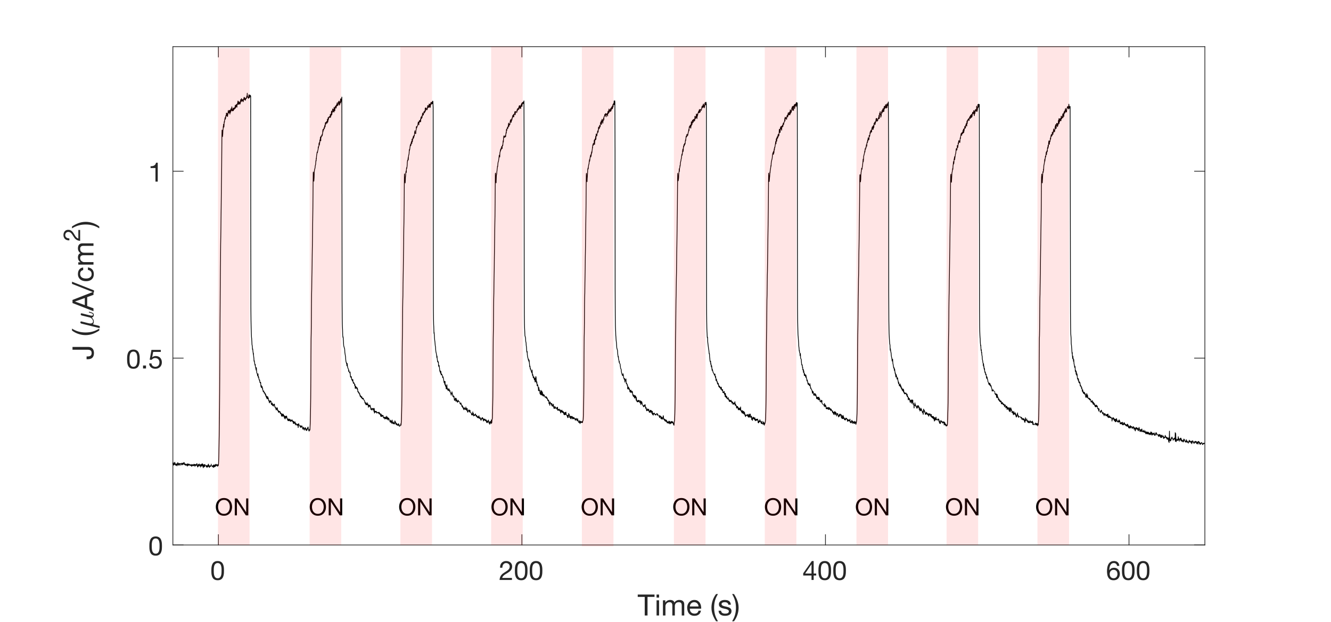

Figure S5: Current density of the detector based on 1L-MoS2 incorporating the scintillator during subsequent irradiations for 20 s of X-rays produced at 100 kV and dose rate 7.05 mGy/s. The detector was operated at 5 V during the measurement.